EXPERIMENT 20: - Write a procedure to showcase the virtual machine migration based on the certain condition from one host to the other.

Step 1: - Open the existing virtual machine

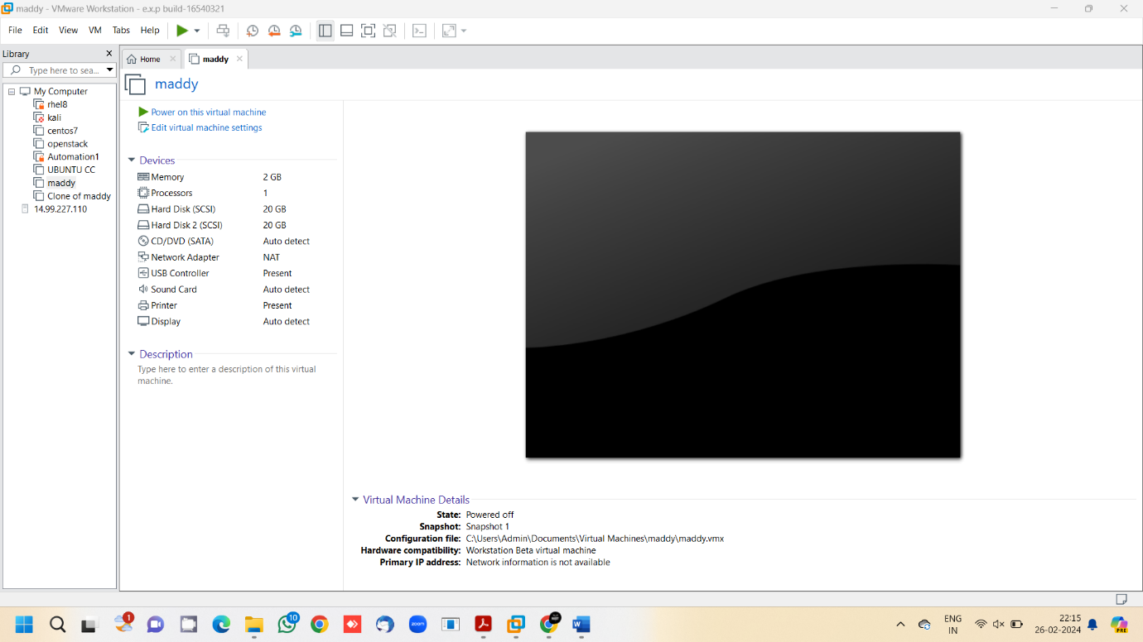

Step 2: - Click on File, export to OVF

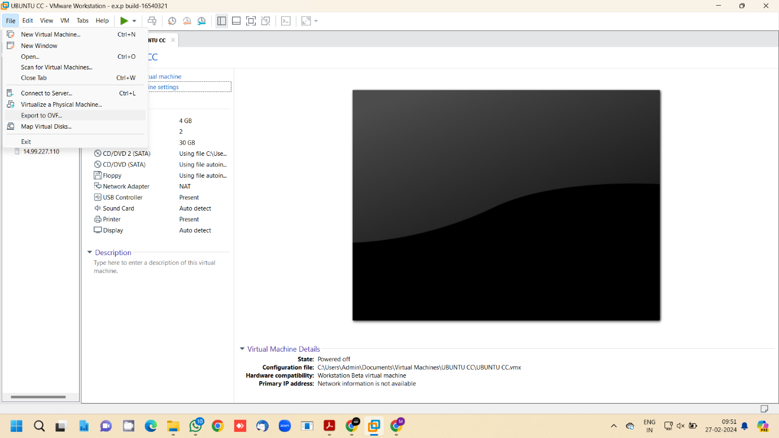

Step 3: - In the new host, click open a virtual machine

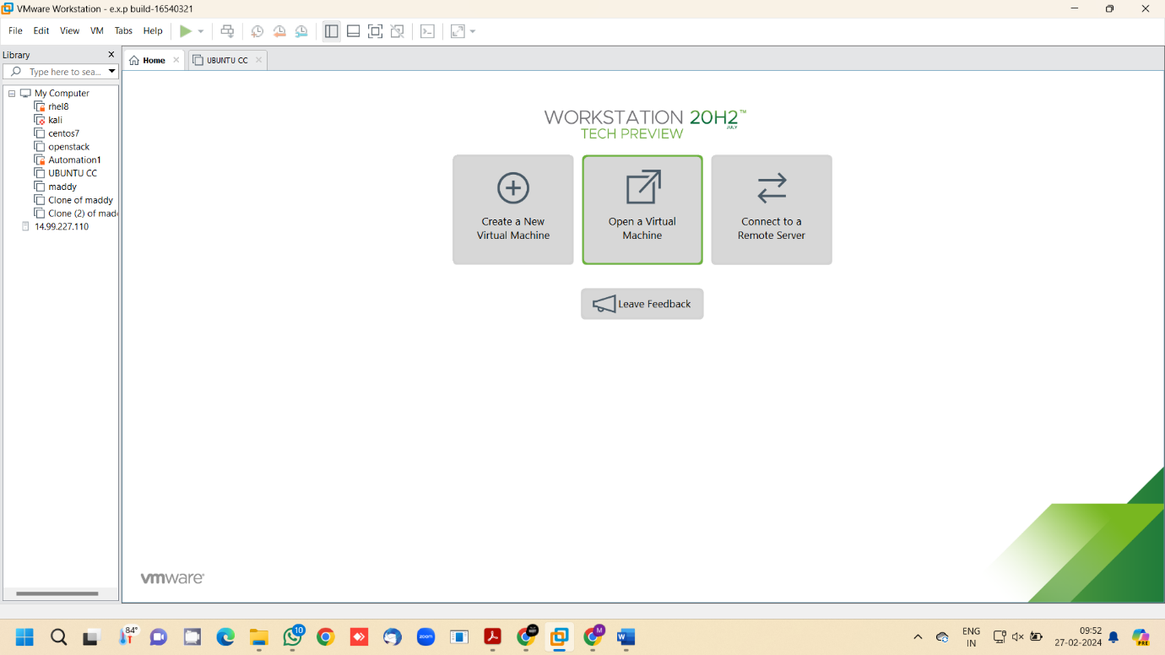

Step 4: - Choose the Virtual machine file and click open

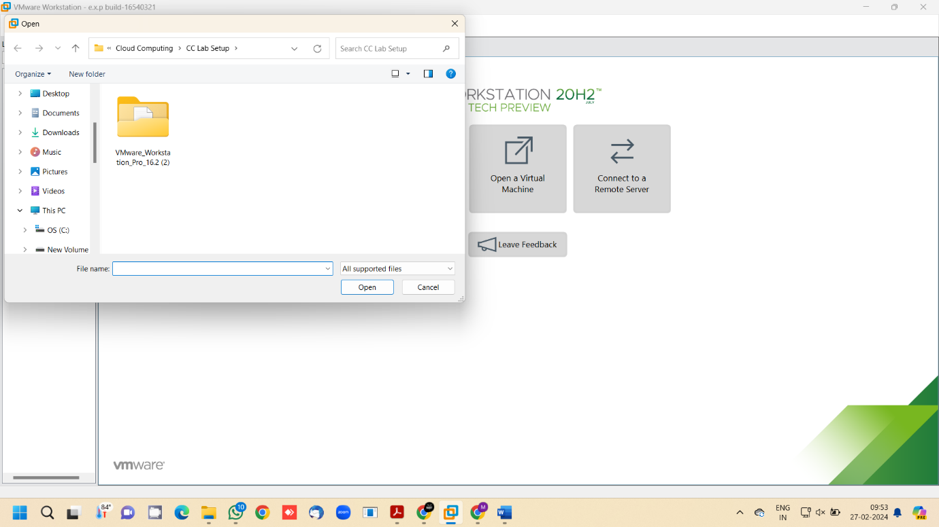

Step 5: - The virtual machine is successfully opened in new host

